WAD ASSIGNMENT 9

const express = require('express');

const app = express();

const port = 3001;

// Middleware to parse the request body

app.use(express.urlencoded({ extended: true }));

// Set up the routes

app.get('/', (req, res) => {

res.send(`

<h1>Welcome to the Express.js web application!</h1>

<form method="post" action="/submit">

<input type="text" name="name" placeholder="Enter your name" required>

<button type="submit">Submit</button>

</form>

`);

});

app.post('/submit', (req, res) => {

const name = req.body.name;

res.send(`<h1>${name} Submitted Successfully!</h1>`);

});

// Start the server

app.listen(port, () => {

console.log(`Server listening on port ${port}`);

});

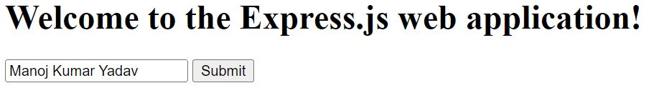  


PS C:\Users\User\Desktop\simple-web-app> node server.js

Server listening on port 3001